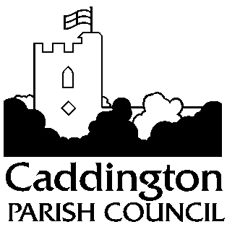
c/o Heathfield Centre
Hyde Road
Caddington

Bedfordshire

LU1 4HF

07912 298141

clerk@caddington.com
www.caddington.com

5th February 2024

To members of the Planning Committee

I hereby give NOTICE and summon you to the next meeting of CADDINGTON PARISH COUNCIL on MONDAY 12th February 2024 at 7:00pm at HEATHFIELD CENTRE, HYDE ROAD, LU1 4HF

L Heartfield
Clerk to Caddington Parish Council

PLANNING COMMITTEE AGENDA

- Receive apologies for absence

- Receive declarations of interest in items on the agenda

- Review Planning Committee Terms of Reference

- Discuss and make comments on planning applications received from Central Beds Council

CB/23/04129/LDCE Brick Kiln Farm, Chaul End Road, Caddington
Lawful Development Certificate Existing: Use of land and buildings for B2 and B8 purposes (Decision by 13/02/2024)

CB/23/03897/FULL Land on the southwest side of Chapel Field, Mancroft Road, Aley Green
Change of use to accommodation for rescued animals. Erection of a residential cabin and ICU areas. Creation of new access, parking, 2 storage buildings, bird enclosure and fox dens with enclosure.
(Decision by 14/02/2024)

CB/23/01840/RM Land Adjoining Dunstable Road And To The Rear Of My Folly And The Scout Hut, Dunstable Road, Caddington
Reserved Matters: following Outline Application CB/17/05679/OUT (Residential Development of 47 dwellings, together with open space) Approval of reserved matters pursuant to outline permission Ref: CB/17/05679/OUT, relating to appearance, landscaping, layout and scale of a residential development of 47 dwellings, together with open space (Decision by 20/02/2024).

CB/24/00257/FULL 56 Manor Road, Caddington, Luton, LU1 4ED
Proposed rear extension. Loft conversion with two front and 2 rear facing dormers. Existing garage to be converted into a habitable space and connected into the rear extension. (Decision by 28/02/2024).

CB/24/00245/FULL 1 Winchfield, Caddington, Luton, LU1 4NE
Garage conversion to home office with roof height increase (Decision by 29/02/2024).

Members of the public will be invited to speak for a maximum of 3 minutes, should they wish to do so.

