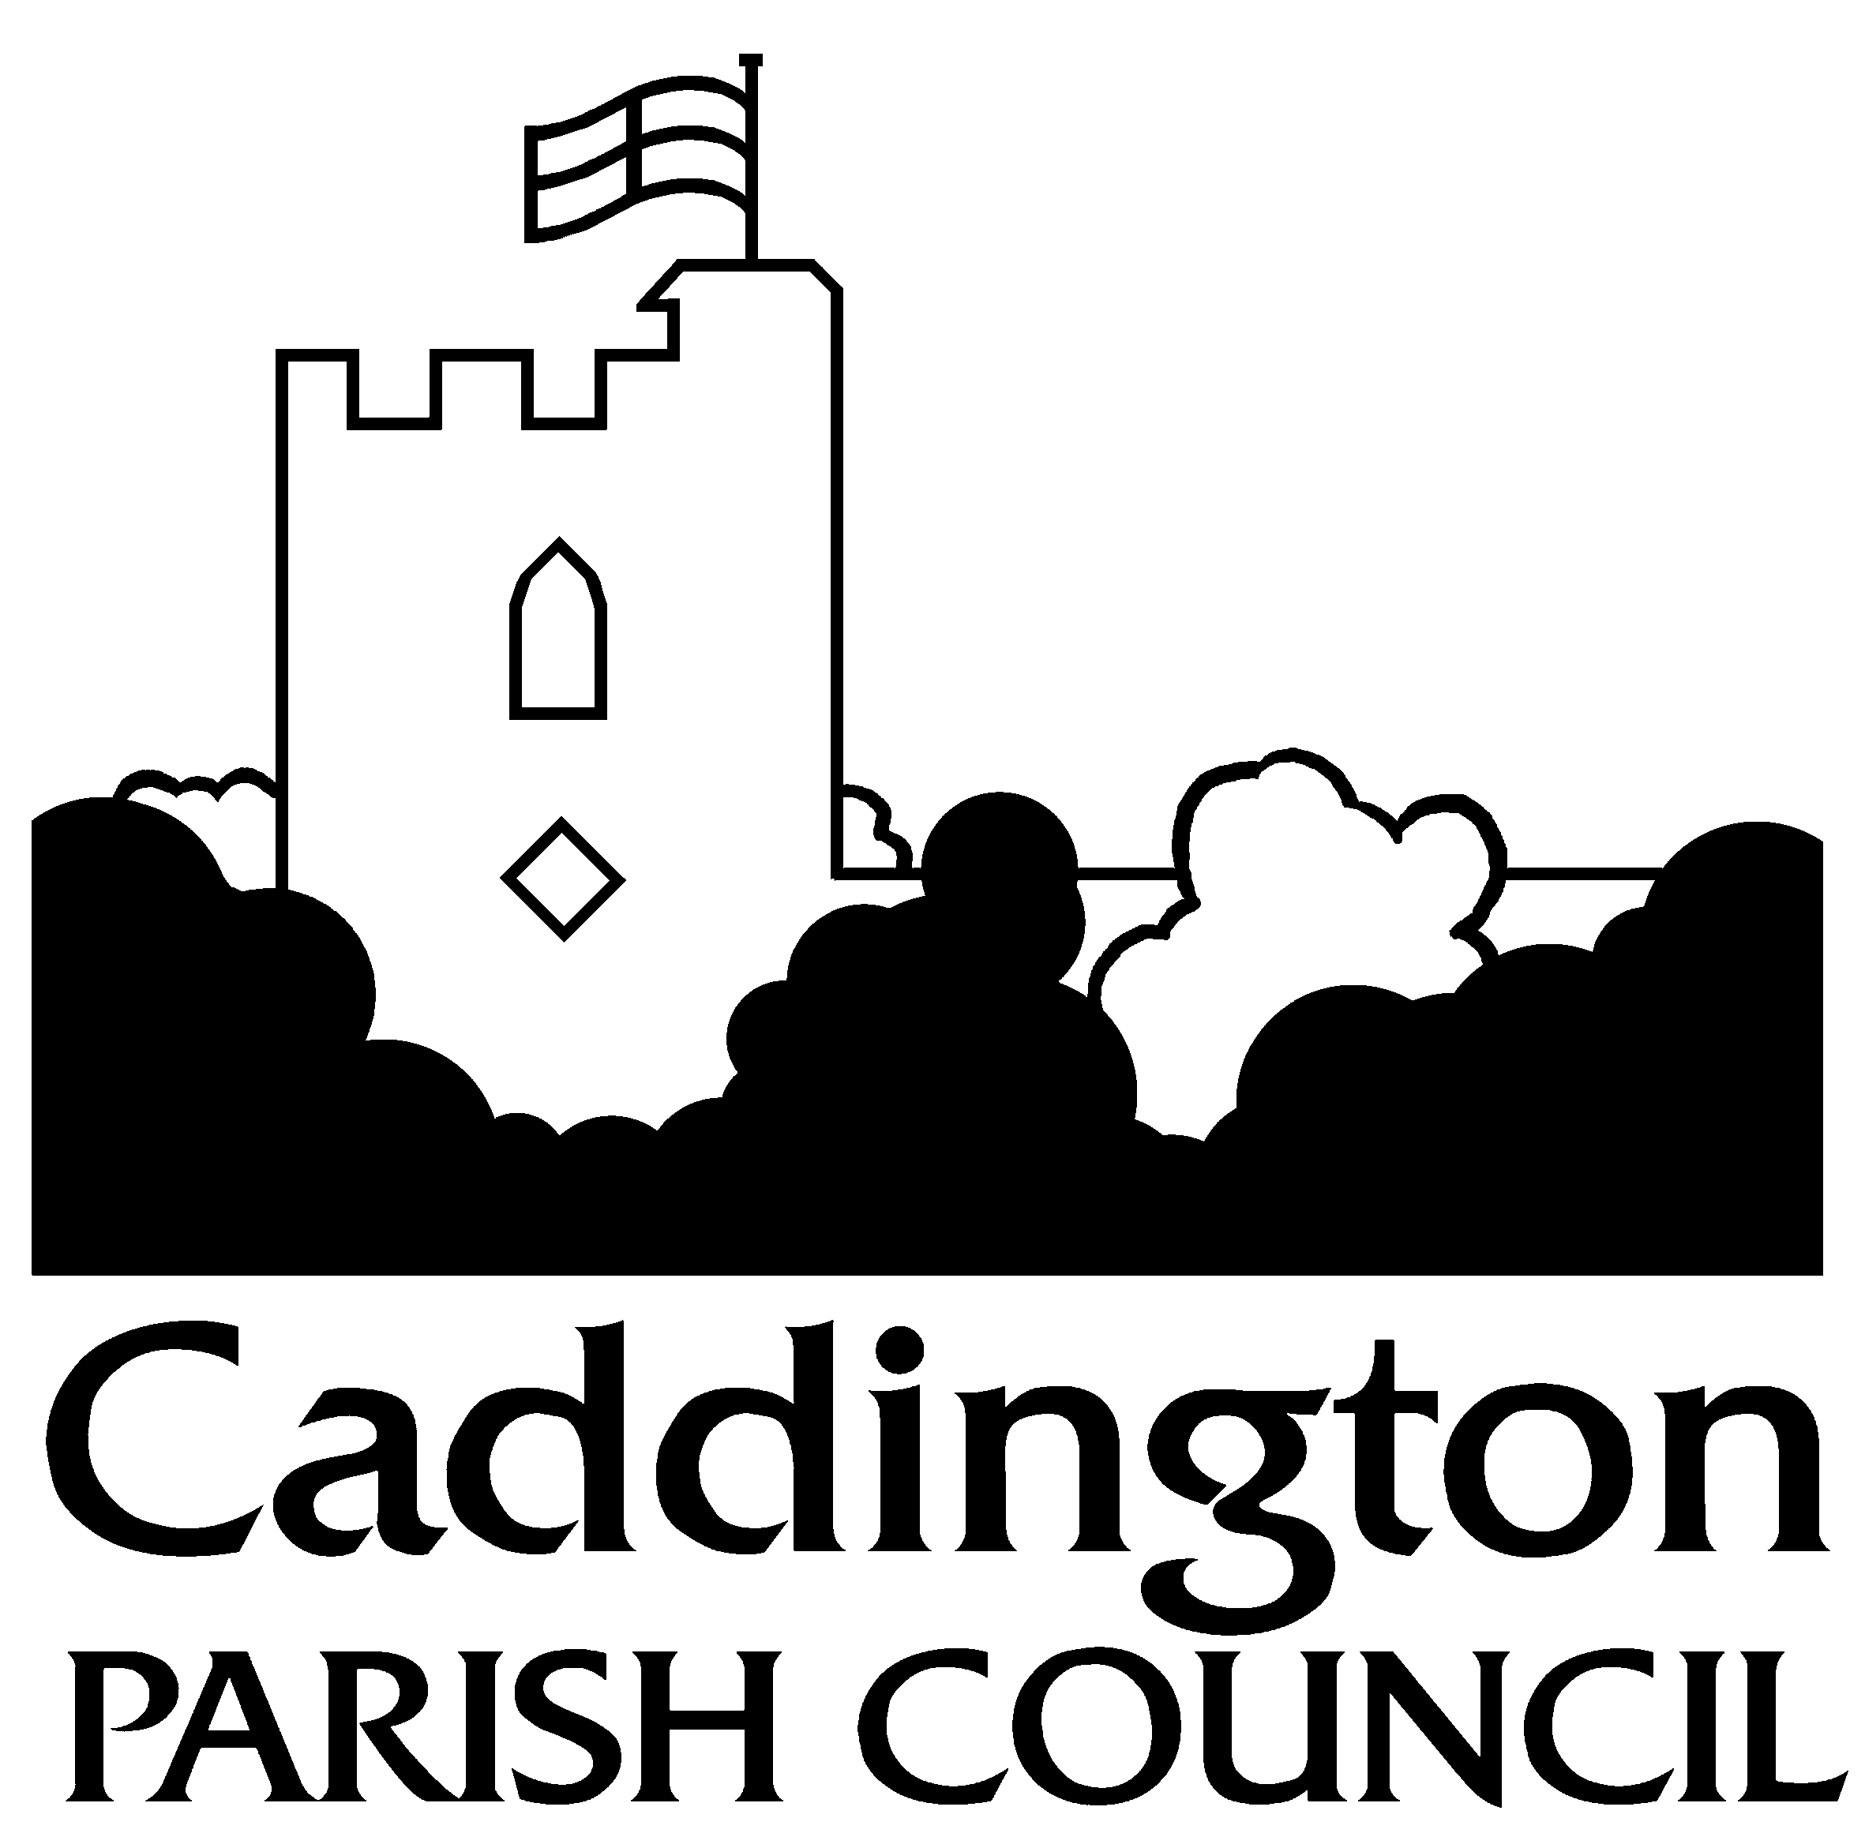c/o Heathfield Centre
Hyde Road
Caddington

Bedfordshire

LU1 4HF

07912 298141

clerk@caddington.com
www.caddington.com

5th September 2022

To members of the Council

I hereby give NOTICE and summon you to the next meeting of CADDINGTON PARISH COUNCIL on MONDAY 12th SEPTEMBER 2022 at 7:30pm at HEATHFIELD CENTRE, HYDE ROAD, LU1 4HF

Members of the Public: Informal public participation will be held from 7:30pm to 7:35pm for members of the public to address the Council.

M Whiting
M Whiting, Clerk to Caddington Parish Council

AGENDA

7:30pm Public Participation for 5 minutes for members of the public to address the Council

- Receive apologies for absence
- Receive any declarations of interest from members in items on the agenda
- Agree and sign minutes of the meeting of 11th July 2022 as a correct record
- Receive progress on resolutions – for information only
- Matters for attention of Police and receive Caddington Watch report
- Receive report from Central Bedfordshire Ward Councillors and discuss CBC items
- Receive update from New Vista Homes on Heathfield Centre development
- Discuss Christmas lights and switch on event 26th November
- Discuss Remembrance Day & twinning Oststeinbek, Germany invitation
- Discuss replacement tree on village green near Chequers & memorial seating request
- Receive quotes for allotment ditch improvements
- Receive quotes for pond improvements
- Receive and discuss actions from Rospa safety reports
- Discuss Rushmore Park and lease renewal
- Discuss 42 The Crescent request to install access gate from rear boundary to Elm Avenue park
- Discuss allotments plot price increase & appoint Cllr representative to Leisure Gardens Management Committee
- Receive Planning Committee minutes and recommendations
- Discuss erection of banners/temporary notices on village green
- Accept and approve the completed 2021/22 annual return certificate from Mazars external auditors
- Receive general correspondence – for information only
- Authorise accounts for payment
- To discuss Parish Warden personnel matters (Members of the public and press excluded due to staffing confidentiality)

Public Participation: 5 minutes for public to gain clarification of any item discussed on the agenda

